The Judgement of God

July 5, 2020

THE LORD’S DAY July 5, 2020

The Celebration of Worship
The Judgment of God
We welcome you to our Communion service this morning and invite to the table all those who believe in Jesus Christ
and are members in good standing in any evangelical church. It is our custom to hold the elements and commune together.

Prelude

Welcome and PPC Family News

Time of Reflection and Preparation

Call to Worship
Leader: Oh, worship the LORD in the beauty of holiness! Tremble before Him, all the earth. Say among the nations, “The LORD reigns; The world also is firmly established, It shall not be moved; He shall judge the peoples righteously.”
All: Let the heavens rejoice, and let the earth be glad; Let the sea roar, and all its fullness; Let the field be joyful, and all that is in it.
Leader: Then all the trees of the woods will rejoice before the LORD. For He is coming, for He is coming to judge the earth.
All: He shall judge the world with righteousness, And the peoples with His truth.
Psalm 96

Exalt the Lord, His Praise Proclaim Trinity 12

Psalm 135, The Psalter, 1912 CREATION: From Franz Joseph Haydn, The Creation, 1798

Invocation and The Lord’s Prayer

Our Father, who art in heaven, hallowed be Thy Name.
Thy kingdom come, Thy will be done on earth as it is in heaven.
Give us this day our daily bread,
and forgive us our debts as we forgive our debtors.
And lead us not into temptation, but deliver us from evil.

For Thine is the kingdom, and the power, and the glory forever. Amen

Confession of Faith
I believe in God, the Father Almighty,
Maker of heaven and earth.
I believe in Jesus Christ, His only Son, our Lord,
Who was conceived by the Holy Spirit,
and born of the virgin Mary.
He suffered under Pontius Pilate,
was crucified, died, and was buried.
The third day He rose again from the dead.
He ascended into heaven
and is seated at the right hand of God the Father Almighty.
From there He will come to judge the living and the dead.
I believe in the Holy Spirit,
the holy catholic church,
the communion of saints,
the forgiveness of sins,
the resurrection of the body,
and the life everlasting. Amen.
The Apostles’ Creed

Scripture Reading
Remember now your Creator in the days of your youth, Before the difficult days come, And the years draw near when you say, “I have no pleasure in them”: While the sun and the light, The moon and the stars, Are not darkened, And the clouds do not return after the rain; In the day when the keepers of the house tremble, And the strong men bow down; When the grinders cease because they are few, And those that look through the windows grow dim; When the doors are shut in the streets, And the sound of grinding is low; When one rises up at the sound of a bird, And all the daughters of music are brought low; Also they are afraid of height, And of terrors in the way; When the almond tree blossoms, The grasshopper is a burden, And desire fails. For man goes to his eternal home, And the mourners go about the streets.
Remember your Creator before the silver cord is loosed, Or the golden bowl is broken, Or the pitcher shattered at the fountain, Or the wheel broken at the well. Then the dust will return to the earth as it was, And the spirit will return to God who gave it. “Vanity of vanities,” says the Preacher, “All is vanity.” And moreover, because the Preacher was wise, he still taught the people knowledge; yes, he pondered and sought out and set in order many proverbs. The Preacher sought to find acceptable words; and what was written was upright-- words of truth. The words of the wise are like goads, and the words of scholars are like well-driven nails, given by one Shepherd.
And further, my son, be admonished by these. Of making many books there is no end, and much study is wearisome to the flesh. Let us hear the conclusion of the whole matter: Fear God and keep His commandments, For this is man's all. For God will bring every work into judgment, Including every secret thing, Whether good or evil.
Ecclesiastes 12

Offertory Prayer

Worship in Giving

Fill Thou My Life, O Lord My God Trinity 589

Horatius Bonar, 1866 ST. FLAVIAN: Day’s Psalter, 1582

Pastoral Prayer

Sermon

Matthew 12:30-37^{NKJV} The Tree and Its Fruit Dr. Ray E. Heiple, Jr.
- He who is not with Me is against Me, and he who does not gather with Me scatters abroad.
- Therefore I say to you, every sin and blasphemy will be forgiven men, but the blasphemy against the Spirit will not be forgiven men.
- Anyone who speaks a word against the Son of Man, it will be forgiven him; but whoever speaks against the Holy Spirit, it will not be forgiven him, either in this age or in the age to come.
- Either make the tree good and its fruit good, or else make the tree bad and its fruit bad; for a tree is known by its fruit.
- Brood of vipers! How can you, being evil, speak good things? For out of the abundance of the heart the mouth speaks.
- A good man out of the good treasure of his heart brings forth good things, and an evil man out of the evil treasure brings forth evil things.
- But I say to you that for every idle word men may speak, they will give account of it in the day of judgment.
- For by your words you will be justified, and by your words you will be condemned.

Notes

THE SACRAMENT OF THE LORD’S SUPPER

How High and How Wide arr. J. Moser, 2006

Words and music by Mark Altrogge © 1991 Integrity’s Praise! Music. Used by permission. CCLI License #173651

Words of Institution and Invitation

Prayer of Preparation

Partaking of the Bread

Partaking of the Cup

Prayer of Thanksgiving

Amazing Grace! Trinity 460

John Newton, 1779 AMAZING GRACE; Traditional American melody, arr. By Edwin O. Excell, 1900

Benediction

Postlude
Following the service, the elders will be available to pray with you at the front of the sanctuary.

The Lord’s Day Evening July 5, 2020

THE CELEBRATION OF WORSHIP
Welcome
Call to Worship ……………………………………………………………………………Psalm 119:9-16
Hymn ………………………………........................................48 O Lord Most High with All My Heart
Invocation
Confession of Faith …………………………………………………………… Shorter Catechism 11-12
Q. 11. What are the works of providence?
A. God’s works of providence are his most holy, wise, and powerful preserving and governing all his creatures, and all their actions.
Q. 12. What special act of providence did God exercise toward man in the estate wherein he was created?
A. When God had created man, he entered into a covenant of life with him, upon condition of perfect obedience; forbidding him to eat of the tree of the knowledge of good and evil upon the pain of death.
Scripture Reading ……………………………………………………………………... Jeremiah 23:16-32
Prayer for the Persecuted Church
Doxology
Praise God from whom all blessings flow; praise him, all creatures here below;
praise him above, ye heavenly host: Praise Father, Son, and Holy Ghost. Amen.

Sermon 1 Cor. 1:17-25 The Indispensable Power of God’s Word Dr. Ray Heiple
¹⁷ For Christ did not send me to baptize, but to preach the gospel, not with wisdom of words, lest the cross of Christ should be made of no effect. ¹⁸ For the message of the cross is foolishness to those who are perishing, but to us who are being saved it is the power of God. ¹⁹ For it is written: "I will destroy the wisdom of the wise, And bring to nothing the understanding of the prudent." ²⁰ Where is the wise? Where is the scribe? Where is the disputer of this age? Has not God made foolish the wisdom of this world? ²¹ For since, in the wisdom of God, the world through wisdom did not know God, it pleased God through the foolishness of the message preached to save those who believe. ²² For Jews request a sign, and Greeks seek after wisdom; ²³ but we preach Christ crucified, to the Jews a stumbling block and to the Greeks foolishness, ²⁴ but to those who are called, both Jews and Greeks, Christ the power of God and the wisdom of God. ²⁵ Because the foolishness of God is wiser than men, and the weakness of God is stronger than men.
Prayer
Hymn ………………………………................................................136 Thy Word Have I Hid in My Heart
Benediction

Notes

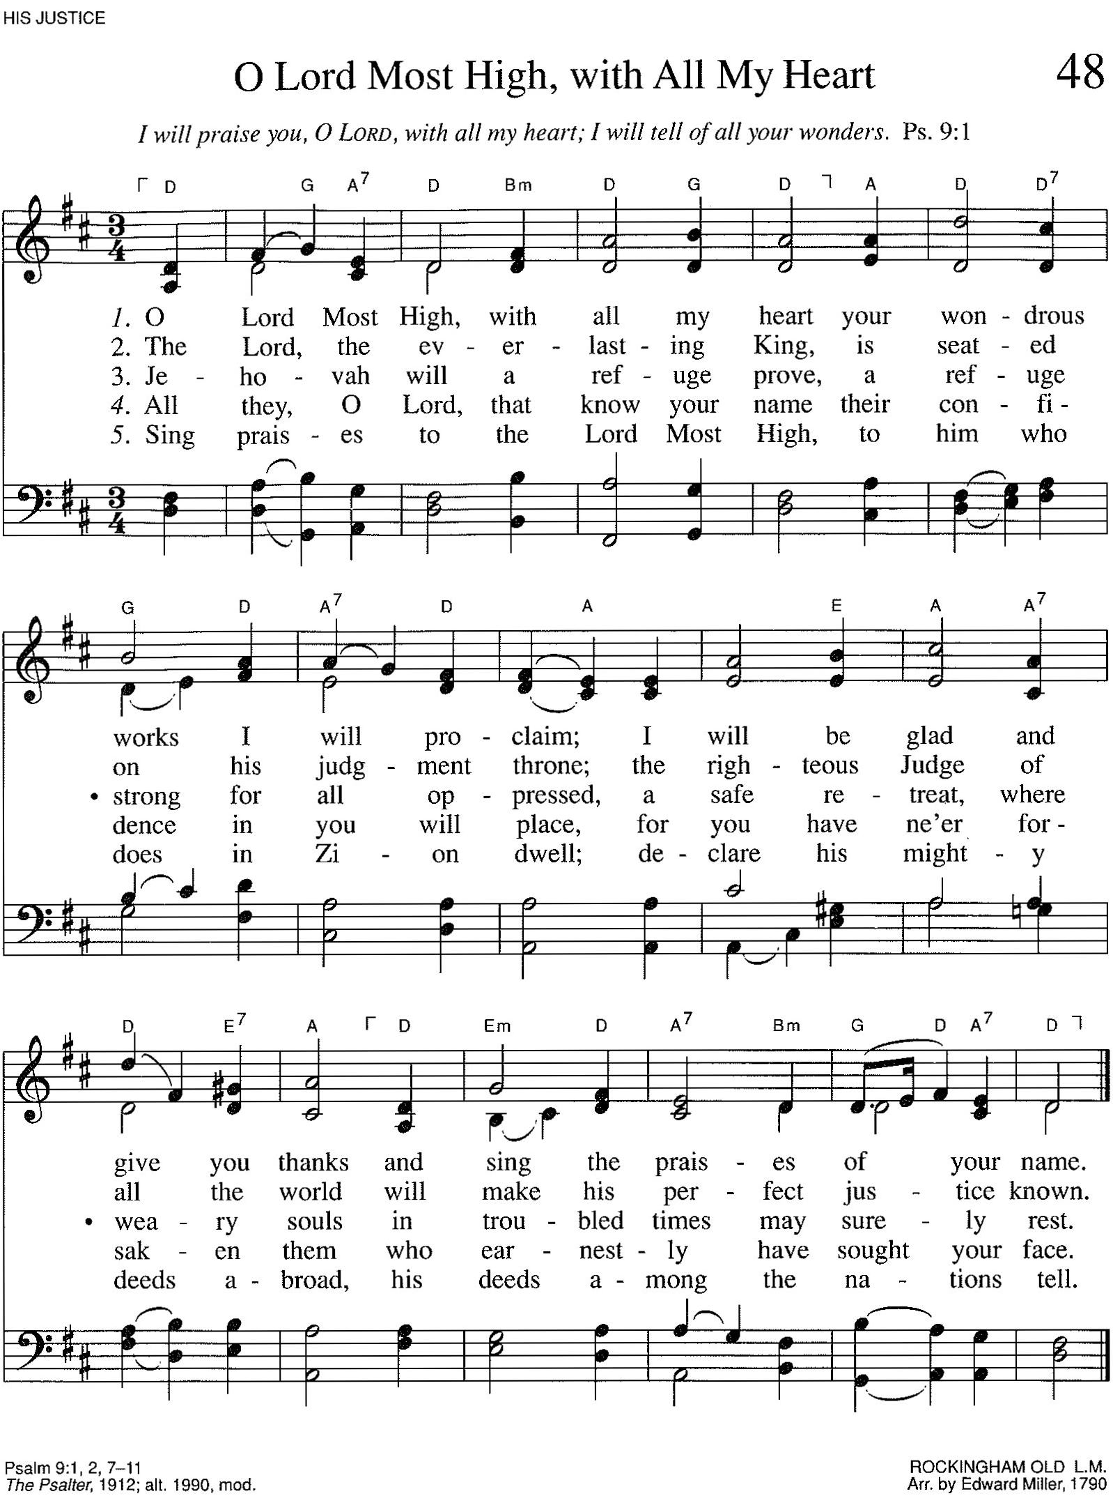

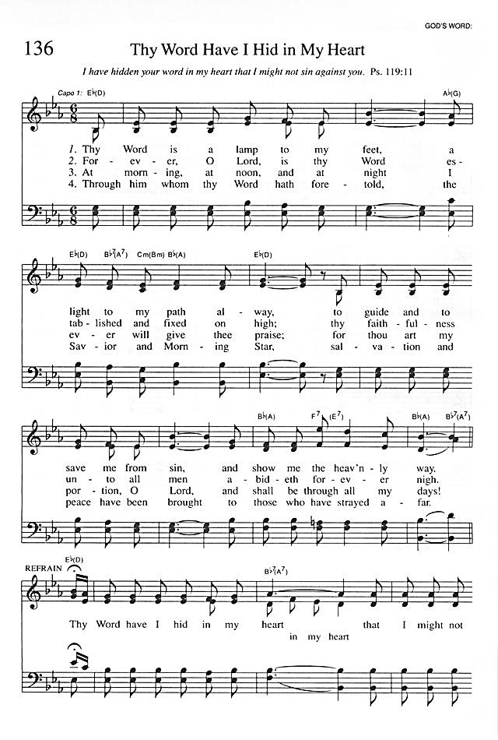
Deacon of the Month: Dave Douglas
Gate Keeper: Lou McCarrell
Greeters: Dan and Christy Martin

Financial Update Through May
2020 Actual Giving | $269,000
Previous Year Giving | $270,000
2020 Budget | $286,000
2020 Expenses | $235,000
Actual Operational Expenses | $235,000
Actual Capital Expenses | $0
Williams Fund | $23,474
Garrett Fund | $21,947
Adoption Fund | $3,352

Schedule for Childcare This Sunday, July 5
Crib Room Danny and Laura Priano 10:30 a.m.
Toddler Room Sonya Eurich and Sonya Campbell 10:30 a.m.

Schedule for Childcare Next Sunday, July 12
Crib Room Dave and Bethany Douglas 10:30 a.m.
Toddler Room Nicole Ongna and Esther Auman 10:30 a.m.
Kids Bible College Pat and Patty Martin 11:00 a.m.

If you have changed your scheduled date
please contact the Church office so we can update this bulletin announcement.

Evening Worship Service
Join us tonight at 6:00 p.m. for our Evening Worship Service. Pastor Heiple will be preaching on 1 Cor. 1:17-25, The Indispensable Power of God’s Word.
Providence Summer Picnic Update
Join us for our first picnic of the summer, July 15, from 6:00 to 8:00 p.m. at Clever Park Rotary Pavilion. The deacons will be providing and serving (or finding volunteers to serve) all of the food (main dish, side dishes, and dessert). This will avoid everyone touching the same serving utensils. A sign-up sheet is available on the information desk in the foyer, or email Karen at secretary@providencepgh.org to sign-up. Please contact Pat Martin with any questions.

2020 Officer Nominations
Nominations for the offices of Ruling Elder and Deacon may be submitted by communicant members in good standing of Providence Presbyterian Church. The office of elder is of leadership and authority. The office of deacon is of service and sympathy. If you believe God is calling a man for either of these offices, submit a nomination form. Forms are available on the desk in the foyer. The form should be completed and returned to the church office by Wednesday, July 8.
Gatekeeper Signup Sheet
The new gatekeeper schedule for August to September is available on the desk in the foyer. Please sign up for the date you prefer. If you have any questions, please see Denny Stewart.
Women’s Ministry Council
The Women's Ministry Council is looking for a small team of experienced mothers to serve together and provide support to new mothers. The commitment would involve taking turns visiting a mom & new baby in their home and being available for support, as needs arise. We would love to have this team available as a resource for practical help and spiritual encouragement to young mothers. If you are interested in this ministry, please reach out to Jamie Dodd at PPCWomensMinistry@gmail.com.
Church Sign Person Needed
We are currently in need of someone to change the church signs each week. Please contact Keith Sellman if you are interested, 412-414-9239.
Thank You
Noreen Parker would like to express her thanks for the love shown to her and Bob, especially for all the cards and letters. They expect Bob to stay at Mercy until the 3rd week of July.
Prayer at Home
Invitation to pray as families in our homes 7:00 p.m. each Wednesday evening while this crisis lasts. Pray for God’s mercy and grace. Pray for our repentance and faith. Pray for God’s protection and sustaining of our families and church.
Ask The Pastors
Each week, Pastors Ray & Rick are coming to you with an ASK THE PASTORS segment. NOW is your chance to ask that burning question you always have wanted answered. Submit your questions to robinheiple@yahoo.com or message us through the PPC Facebook page and we will be sure to have the pastors answer your question!

Providence YouTube Channel
In addition to our livestream of morning and evening worship, each week we are creating new content to keep us connected as the body of Christ.
Tuesdays: ASK THE PASTORS with Pastors Ray Heiple & Rick Appleton
Wednesdays: Walking with God, a journey in Psalms with Pastor Heiple
Fridays: Pastor Rick’s Catechism Challenge

Tithes and Offerings Update
The giving of our tithes and our offerings is important aspect of worship. During this time we wanted to provide an update on the ways you can give. You can now give on-line through our recently redesigned website at https://www.providencepgh.org/give. After clicking ‘Give now’, you will be redirected to a secure hosted payments page. We encourage you to utilize the ‘One-Time’ payment option (as opposed to the “Recurring” option) each time you visit the website, as we believe this is more consistent with the regular (weekly) act of returning a portion to the Lord.
The on-line giving page will accept offerings via checking/savings account or by credit/debit card. There is no cost to you either way, however if you choose the credit/debit card option, the church will incur a processing fee of approximately 2.5%-3.5% of the offering. The church incurs virtually no fees when the checking/savings account option is utilized. Other than passing along any credit/debit card processing fees, this service is being offered to us free of charge for the next few months by the PCA Foundation.
Additionally, you can always mail your offering to the church office at 77 Phillips Lane Robinson Township, PA 15136. If you have any questions, please reach out to your ruling elder.

PRAYER REMINDER

To become a prayer partner or place a prayer request with the prayer chain,
please call or email
Jan T. 412-787-1609, janandgerry6@verizon.net
Please notify the Church office by phone at 412-788-6100, or email at
secretary@providencepgh.org if you have any additions, deletions,
or updates to the bulletin Prayer Reminder.

Members of PPC
Leslie H. prayer for recovery from surgery to replace her missing skull piece
Linda S. prayer for recovery from ankle reconstruction surgery
John O. prayer for recovery from open heart surgery
Katrina C. prayer for recovery from a fractured shoulder and for pain relief
Bill D. prayer for recovery from knee surgery
Nate and Judith D. praise, expecting in November
Jon and Jamie D. praise, expecting in August
Joe and Kierstan G. praise, expecting in August
Chris and Sarah H. praise, expecting in October
Cody and Dori M. praise, expecting in November
David and Rachel M. praise, expecting in July
Bob P. prayer for continued recovery, Bob is getting physical therapy on his legs at this time. He gets tired easily from the therapy but is giving it his best effort.

Friends of PPC
Judy Lewis and Alena H. friend – prayer Judy is a young mother with 2 children, has stage 4 cancer which has moved from her colon to her lungs.
Patty H. Eli and Betty Jane D. daughter – prayer for medication and treatment to work well
Lauri R. Bob and Noreen P. daughter – prayer for recovery from brain surgery with no complications or infections

Bold and italic - new or recent request

Ministry Contacts

Building Use Team.................................................................................................Denny Stewart

Childcare Scheduling Caroline Richard

Christian Education Team Dave Douglas/Brandon Pickett

Communion Scott Ferguson

Church Life Team Gerry Timberlake/Denny Stewart

Fellowship Hall Sports/Recreation.....................................................................Patrick Martin

Food Bank Patrick Martin

Funeral Luncheons......................................................................................................Gail Burford

Greeters Patty Martin

Hospitality & Assimilation....................................................Denny Baker/Paul Deffenbaugh

Kids Bible College Dean Falavolito

Missions Don Maurer/Bob Alouise/Denny Baker

Music Ministry Frank Moser

Newsletter....................................................................................................Brian & Rachel Jones

Outreach......................................................................................................................Dan DeFazio

Pioneer Clubs Jan Eisenbach

Prayer Chain Jan Timberlake

Prison Ministry Jim Stuart

Security Committee Denny Stewart

Sermon Library Keith Sellman

Sound System Scott Ferguson

Special Events Trey Jackson

Sunday School. Jessica Johnson

Treasurer Nate Johnson

Ushering Patrick Martin

VBS Nicole Ongna

Wedding Coordinator Kierstan Grondziowski
Women’s Ministry.......................................................................................................Lisa Boelcke

Effectual Calling, an Overview
But we are bound to give thanks to God always for you, brethren beloved by the Lord, because God from the beginning chose you for salvation through sanctification by the Spirit and belief in the truth, to which He called you by our gospel…
2 Thessalonians 2:13-14a^{NKJV}

Question 67 of the Larger Catechism, asks, “What is effectual calling?” It gives the answer, “Effectual calling is the work of God's almighty power and grace, whereby (out of his free and special love to his elect, and from nothing in them moving him thereunto) he doth, in his accepted time, invite and draw them to Jesus Christ, by his Word and Spirit; savingly enlightening their minds, renewing and powerfully determining their wills, so as they (although in themselves dead in sin) are hereby made willing and able freely to answer his call, and to accept and embrace the grace offered and conveyed therein.” Last week we looked at the believer’s union with Christ. This week we consider the Biblical doctrine of effectual calling.

Effectual calling often reminds me of growing up in Saltsburg and playing outside after school. Every evening the kids would gather in a different yard and play (we had the yard where we played football, the yard that was best for kickball, another one for whiffle ball, etc.), until our fathers called us home for supper. As each dad called his own children, they would respond by leaving the game and running home to eat. Now sometimes you would be tempted to delay leaving, like when the game was particularly competitive, or when you were on the verge of scoring, and sometimes you didn’t hear your dad when he called. But you could always tell from the tone, when a father had to call the second time however, for it was louder and a lot more insistent! When my Dad called us that way, we came immediately, no matter what was happening in the game! Thus, this second call was effectual, in that it always achieved the goal for which it was given: when Dad called, we came willingly! So also, when the sovereign and almighty Creator and Sustainer of the universe acts to call His elect from spiritual death to spiritual life, they invariably and irresistibly respond to that call, so that those who were spiritually dead immediately live!

While this illustration accurately pictures the authority and power of the caller and the outward effect of the call, it fails to convey the special grace of God in effectual calling, and the inward and spiritual transformation that His call accomplishes in the hearts of His people. We came when our dads called, mostly out of fear of punishment, mixed with a little respect, but with very little real desire to stop playing so that we could go in and eat! Earthly fathers simply do not have the power to change the hearts of their children in order to make them want to obey them. Only God can change the heart. Additionally, the children in my example already possessed the ability to respond to their fathers’ calls. They are not by nature hostile toward their fathers (Rom. 8:7), alienated from and enemies of their fathers (Col. 1:21), and haters of their fathers (Rom. 1:30). But Scripture declares that we are born with all of these attitudes toward God.

Accordingly, the effectual call of God to salvation is not merely a call to outwardly do something, but to inwardly admit our sins, trust in Christ, and live a life of loving obedience to God. God calls us into spiritual life from spiritual death. That is, in effectual calling, God causes those who reject Him, hate Him, and hate righteousness and truth, to receive Him, love Him, and love righteousness and truth. While earthly fathers want their children to be sincere in their obedience to them, they do not have such lofty goals for true inward transformation when they call their children home for supper. They just want them to come in and eat! Furthermore, unbelieving earthly fathers call their children out of a natural love for them. They love their children in the way that they love themselves, as an extension of themselves and their own enjoyment of life in this world. They want to see their children have a good life, in the way that they want a good life for themselves: maximizing pleasure, minimizing pain, and having honor before men. Only the Christian father can truly love his children (1 John 4:7), seeking their spiritual and everlasting good, not only in this world but in the next, and seeking for their honor not before men, who are and love evil, but from the God who alone can give true honor. The Christian father’s love to his children desires most of all that God would save them, that God would love them unto salvation. In effectual calling, God begins to communicate this kind of love to the elect, for in effectual calling God’s grace powerfully regenerates His enemies into His children. Lord willing, next week we will look at what that means.
Pastor Heiple
